**Start with R**

**1) Use R to figure out how many elements in the vector below are greater than 2.**

**rooms <- c(1, 5, 2, 1, 3, 1, NA, 3, 1, 3, 2, 1, NA, 1, 8, 3, 1, 4, NA, 1, 3, 1, 2, 1, 7, 1, NA)**



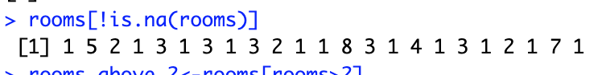  
*I have now stripped of the missing data (NA)*



The object “rooms_no_na” is now equal to “rooms” without the missing data

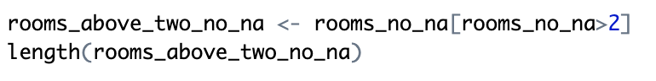

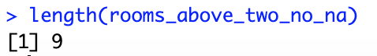

I made an object “room_above_two_no_na“ and assigned it to all values in “rooms_no_na” above two with the function >2.

Afterwards I used the function “length” to tell how many elements there are greater than two in “rooms_above_two_no_na) which was 9.

**2) Which function tells you the type of data the 'rooms' vector above contains?**

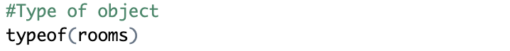



“Double” is the same type of data as “numeric”

**3) What is the result of running the median() function on the above 'rooms' vector?**

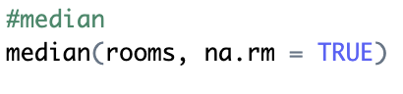



I used the function “median” to find the median of the “rooms” vector. To strip out the missing data (NA) I used the function na.rm = TRUE.

**4) Submit the following image to Github: Inside your R Project (.Rproj), install the 'tidyverse' package and use the download.file() and read_csv() function to read the SAFI_clean.csv dataset into your R project as 'interviews' digital object (see instructions in https://datacarpentry.org/r-socialsci/setup.html and 'Starting with Data' section). Take a screenshot of your RStudio interface showing**

**a) the line of code you used to create the object,**

**b) the 'interviews' object in the Environment, and**

**c) the file structure of your R project in the bottom right "Files" pane.**

✓ - Done

**Save the screenshot as an image and put it in your AUID_lastname_firstname repository inside our Github organisation (github.com/Digital-Methods-HASS) or equivalent. Place here the URL leading to the screenshot in your repository.**

<https://github.com/Digital-Methods-HASS/au728045_Corvalan_Kristian/blob/main/Sk%C3%A6rmbillede%202023-09-26%20kl.%2010.25.50.png>